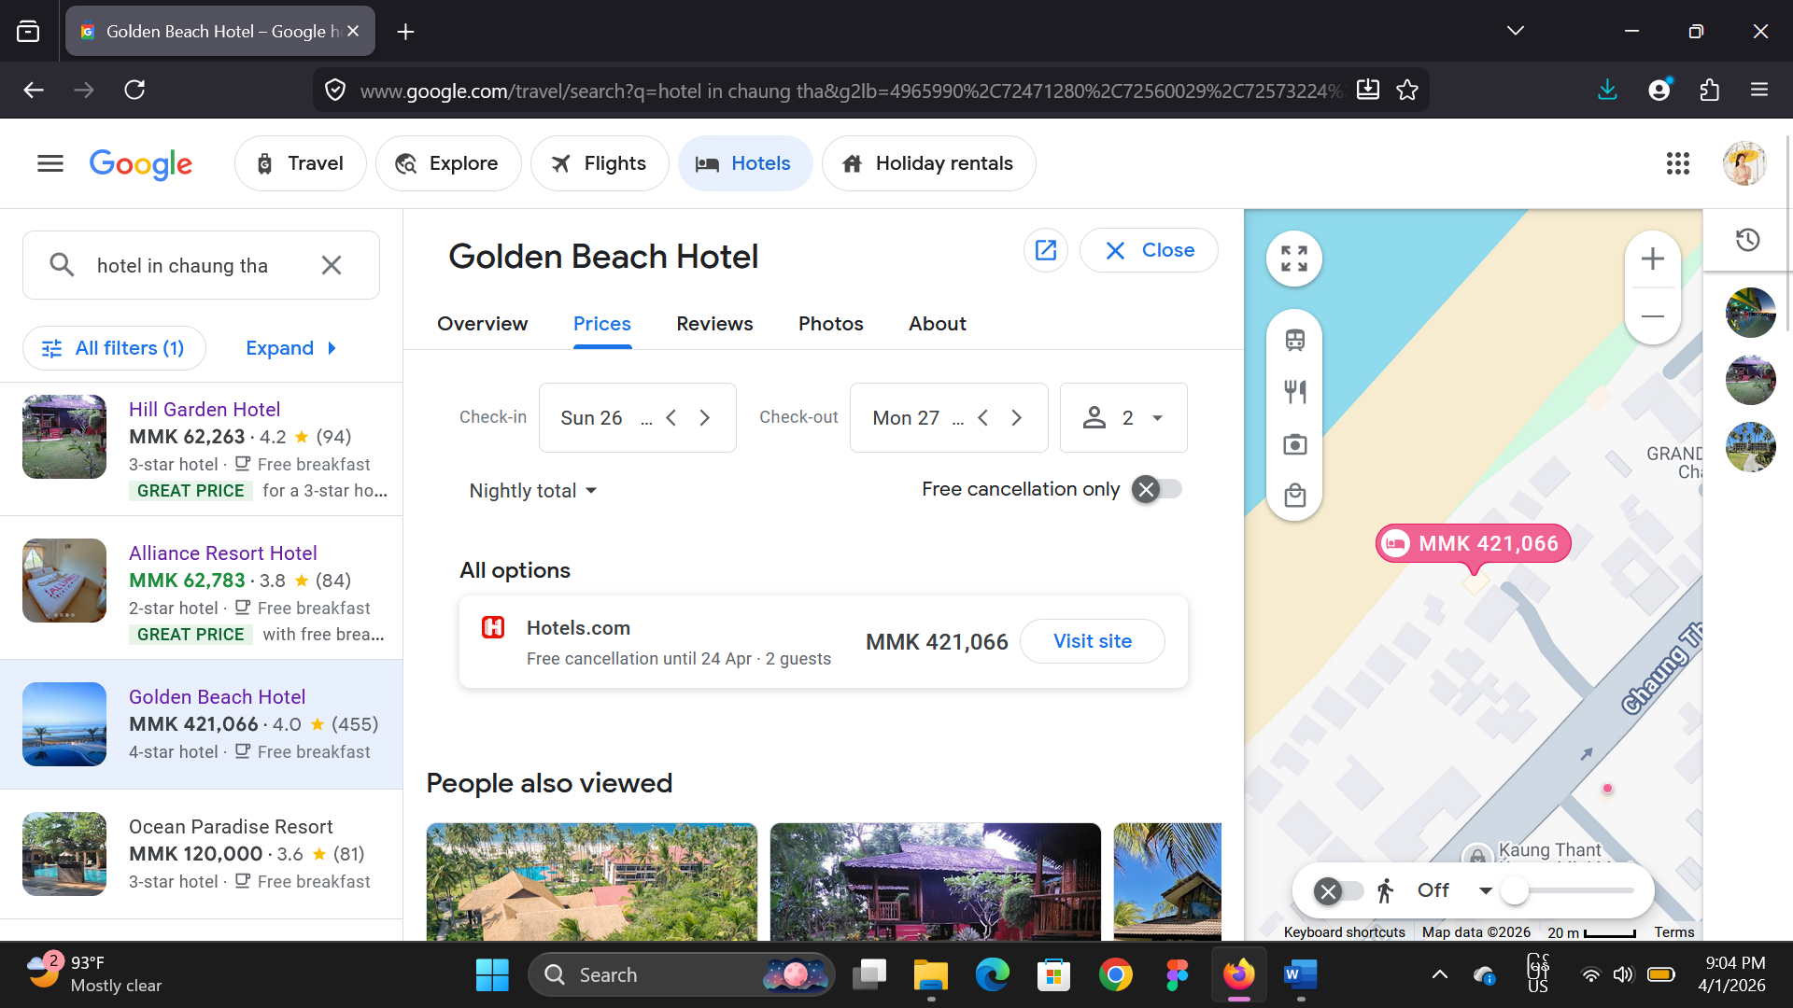

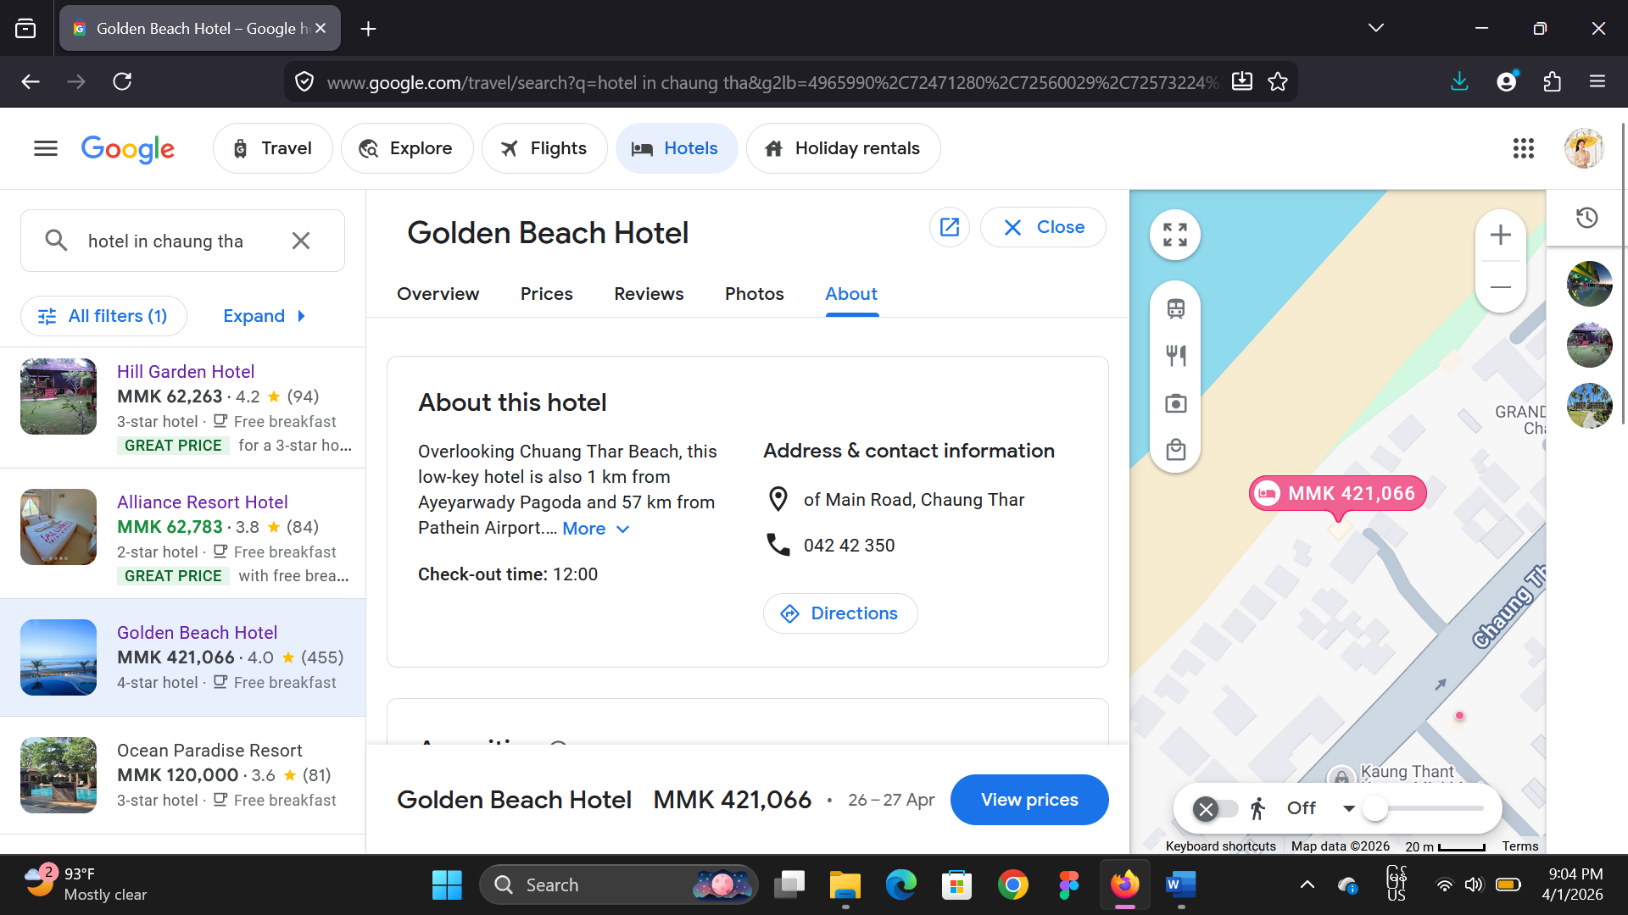

link
https://www.google.com/travel/search?q=hotel%20in%20chaung%20tha&g2lb=4965990%2C72471280%2C72560029%2C72573224%2C72647020%2C72686036%2C72803964%2C72882230%2C72958624%2C73059275%2C73064764&hl=en-MM&gl=mm&cs=1&ssta=1&ts=CAESCgoCCAMKAggDEAAaVgo4EjQyJTB4MzBiZmI0NzhhOTJlZDU1MzoweGMzZDhiZjA3NTNhZGZiNDc6C0NoYXVuZyBUaGFyGgASGhIUCgcI6g8QBBgaEgcI6g8QBBgbGAEyAggBKg8KBToDTU1LGgAiBAoCEAE&qs=CAEyJ0Noa0l3b0tXMXBDQV9zXzNBUm9NTDJjdk1YQjBkMkp4ZHpWeUVBRTgKQgkRkK1Nsgy8-bdCCRFmK-dBjSh6YkIJEULd2BiYYYxnSABaTDJKqgFHEAEqCSIFaG90ZWwoADIfEAEiG4tkzDzH0dpqsMuWP6v2vZm1W_mnSB-6JS5CBDIXEAIiE2hvdGVsIGluIGNoYXVuZyB0aGE&ap=KigKEgnwepfvU_owQBEFjInb5JxXQBISCcRr2skD-zBAEQWMia8BnVdAMAC6AQdkZXRhaWxz&ictx=111

